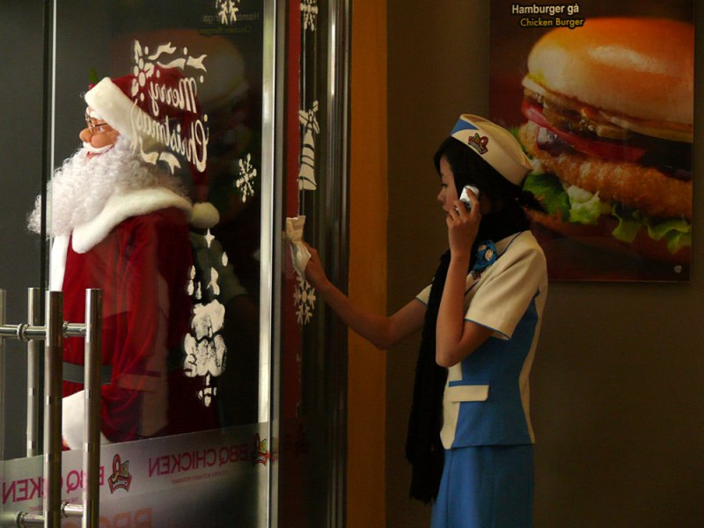

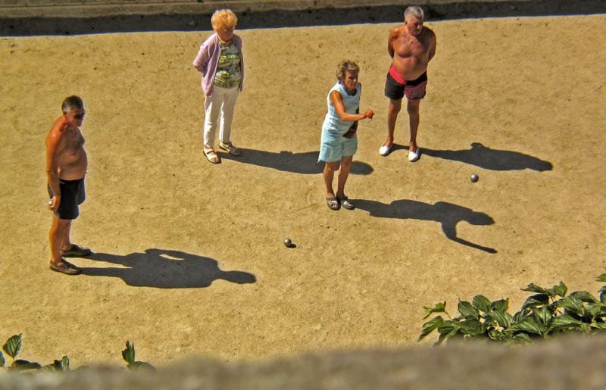

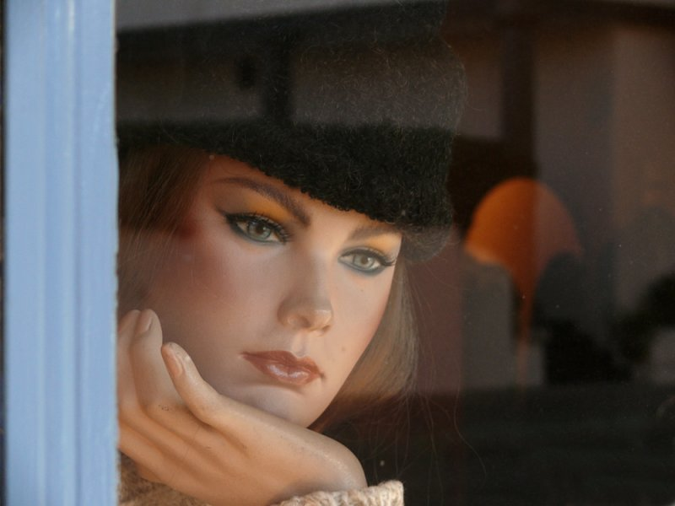

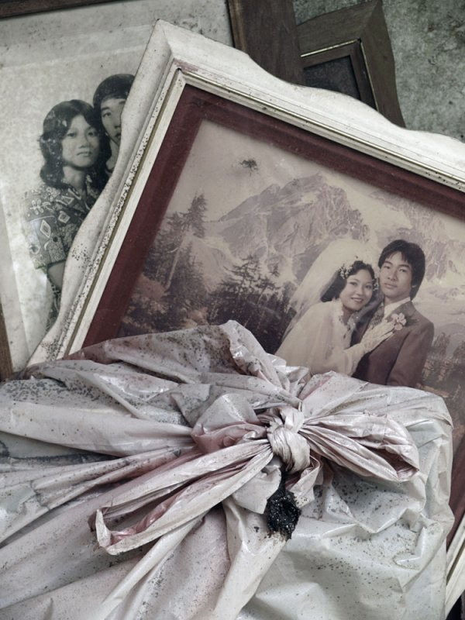

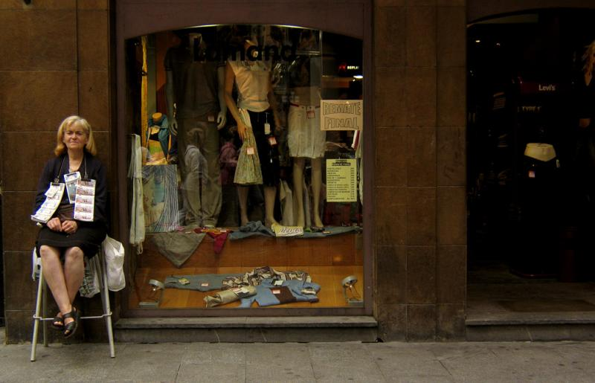

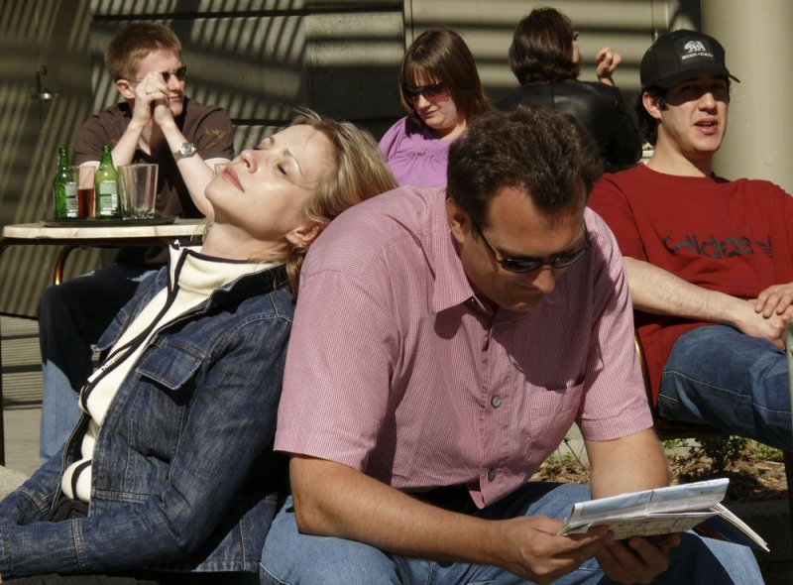

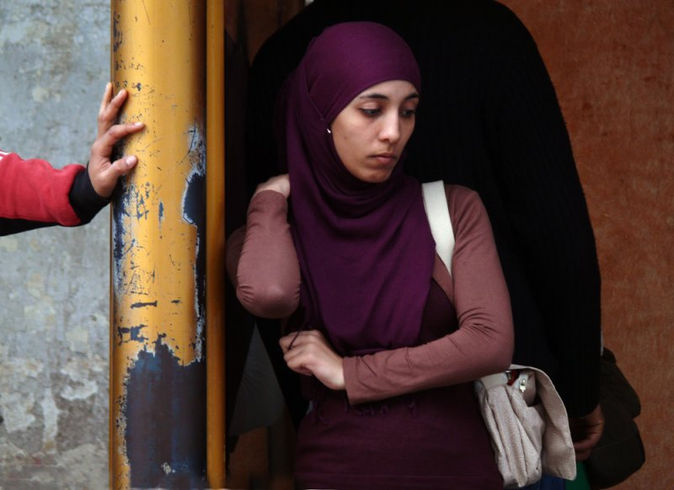

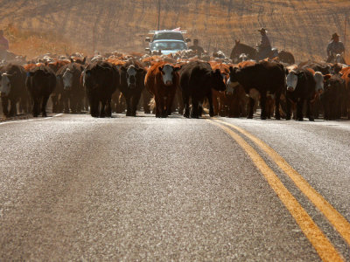

Multitasking, Hanoi, Vietnam, 2007
A fast-food worker chats on her cell phone while cleaning her restaurant's front door. She is squeezed between reminders of her job -- a huge hamburger -- and the holiday enticement that stands just beyond the glass. The image tells the story of how people juggle their priorities. We can be sure she is not talking to someone about the job she is doing – she wipes that door with the practiced hand of an automaton, and her back is turned to the juicy hamburger on the wall. Since relatively few Vietnamese celebrate Christmas (the holiday is promoted here largely for western tourists) we can assume that she is not particularly enamored with Santa, either. My hunch is that she is talking to her boyfriend, girlfriend, husband, or significant other. Ultimately, each viewer will decide where her priorities rest.
- Shadow game, St. Malo, France, 2004
Vantage point is everything in street photography. Sometimes we can shoot close in, while other times we must back away. Every now and then we can find a spot where we won’t be seen at all, such as from high up on the ramparts that enclose the ancient city of St. Malo, France. While shooting down from on St. Malo’s lovely beaches, I noticed this quartet enjoying a friendly competition. Then I looked again at the scene, and from this particular angle, their shadows incongruously become players as well. Four become eight, and the ball the lady is tossing is suspended in the air. Yet the ball in the air also looks very much like the one sitting on the ground. The only way we can know if her ball is in flight is because is because the ball on the ground casts a small shadow, while the ball in the air does not. Although this is technically a beach and not a street shot, there really is no difference. Both are about the inter-relationship of people in public spaces, and both are about the meaning of moments captured in forever in time.
Shadows are always fascinating in street photography, because they become symbolic extensions of the people who cast them. In this case, the four shadows seem to become part of a game.
I am more conscious than ever about the role of shadows in my street photography, because of what I’ve learned from pbase photographer Jen Zhou’s street imagery. Click on the thumbnail at the bottom to see Jen’s shot of a pacing Shanghai cab driver.
It continues to haunt me – I see it now whenever I am looking down at a scene from above on a sunny day, and it causes me to find meanings in my images that I might not have even considered before seeing Jen’s shot. My own Shadow Game was inspired by Jen’s taxi driver image, which I first saw only a few days before I left for Europe. While I did not copy her concept, I was certainly aware of it as I shot. There really are no new ideas in photography. There are only new ways to express old ideas.

- Patience, Santa Fe, New Mexico, 2007
When I saw her looking out of a Santa Fe shop window, I instinctively raised my camera and made this image. Softened by the reflective windowpane, she both looked and felt real at that first glance. But Santa Fe is a place of illusions -- what seems real at first, often proves to be unreal, the stuff of fantasy. Her hand in chin gesture and facial expression evokes great patience. She will continue to wait and watch from this window without movement, sight, or thought.

- Wedding photograph, Pulau Ubin, Singapore, 2007
On our walk around Ubin Island, a rural suburb just off the shore of Singapore, we visited a home that seemed to be abandoned. Its rambling, overgrown grounds resembled an outdoor attic. I found this faded, soggy wedding picture on the ground behind the house, stacked underneath a dirty plastic garbage bag. The incongruously smiling bride and its idealized background could tell a story of unrealized dreams, a failed marriage, discarded memories, or even tragic loss. I de-saturated my own image in post processing, fading the picture to make it echo the faded colors of the wedding picture, still wearing it’s ornate frame. Other framed photographs, possibly of the same people, peek out from below – reinforcing the sad story of the wedding picture and garbage bag that overwhelm them.

- Lottery ticket seller, Bilbao, Spain, 2004
My story here is simple -- either buy a lottery ticket from her and hope for the best, or catch a good deal on clothing while you can. I saw it as soon as I framed the shot – the symbol of the Spanish lottery saleswoman crossing her legs before her on the stool, juxtaposed against the symbolism of a store window filled with bargains, and also featuring legs – this time the legs of manikins. This picture is one of those rare hybrids – it is actually an environmental portrait of the sales lady, but because of the strong relationship between her job and the bargain basement prices in the window, this picture is most certainly a street photograph as well.

- Café, Union Square, San Francisco, California, 2007
Six people sit in the sun, taking it easy. The woman closest to the camera tries to sleep. Her companion offers his back as a pillow while he studies a map of the city. The fellow in the bright red shirt comments on the flow of tourists from around the world walking through the square. The man with all the beer watches the watchers, a woman reads, and another man turns his back on the whole thing. This image tells a collective story, defining a moment in time where each person in this group becomes an individual by using body language or gesture uniquely.

- Waiting for the tram, Tunis, Tunisia, 2008
This image is all about hands, arms, and space. The woman waiting for her tram creates a square with her arms, as if subconsciously defending her space. She leans on a wall as she waits, while a man leans on a post adjacent to that wall. I cropped him out of my frame, leaving only his arm and hand to press against that post. The woman ignores his presence, yet we can feel the tension generated by the intrusion of the man’s hand into the frame. The battered post adds context – it is a well-worn barrier, separating two strangers in space.

- Cattle-drive, Henry, Idaho, 2006
Our van was held up for fifteen delightful minutes by a cattle-drive right up the center of the highway. Most of my shots were made through the open door of our van as these cattle flowed past us, but early on, when we first spotted them coming at us from a distance, I was able to spend a few precious seconds shooting from the middle of the highway. I took the lowest vantage point I could, lowering my camera to almost pavement level and looking down into my flip out viewfinder at the on-coming herd. I placed the double yellow line at the lower right hand corner of my frame, so that it would lead the eye into the heart of the herd. They were coming at me up a long slope, and I shot just as they reached the crest. The yellow line rises and then begins to fall as it vanishes into the herd. Cowboys on horseback drive the cattle from the rear, and traffic backs up behind them. My 420mm telephoto lens collapses the distance between these elements, and makes the distant field seem as if it is an earthen wall at the back of the image. This photograph is essentially a product of my own perspective. It is far more expressive than any of the images I made by shooting down on the cattle from our van as they passed us by, because my ground level perspective vicariously puts the viewer directly into the path of the oncoming herd.

**Source: http://www.pbase.com/pnd1/root
All photos and captions by Phil Douglis

