

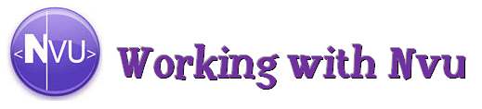

What is Nvu?

- Nvu is a program that allows you to design webpages that you can in turn upload to the Internet. A new Nvu page is considered a blank HTML document. However, you don’t need to know HTML code to create a webpage on Nvu. In fact, in designing a webpage, you’ll use many of the skills you would in designing a Microsoft Word document or PowerPoint slide. Even Nvu’s toolbar is quite similar to those found in most Microsoft Office programs:

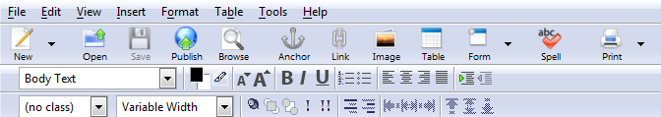

- In designing a webpage on Nvu, you can include many of the features of a typical website. In this handout, you’ll find information on how to:
  - Save your webpage(s)
  - Add text
  - Add images
  - Add tables
  - Add music and video
  - Upload your webpage(s) to the Internet

Saving Your Webpage(s)

- When designing a new webpage in Nvu, you’ll want to begin by saving the page, even if all you have is the “blank HTML document.”

- To save, click “File” at the top, and in the dropdown menu, click “Save As…”; the following window will pop up:
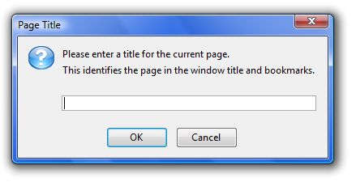
The above window will ask you to title your webpage. This “title” is what will appear as the name of the webpage when opened up on an Internet browser. For example, if you write in “My Awesome Page,” this is what will appear on an Internet Browser:

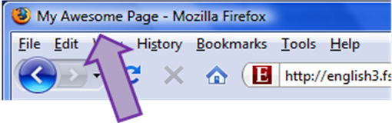
- After titling your webpage, a window will pop up for you to save your webpage. Before you save, you’ll want to create a new folder (perhaps on the desktop) to save all of your Nvu files.

  - Note: All Nvu webpages as well as other documents and images inserted into an Nvu webpage need to be saved in the same folder.

- When saving your Nvu webpage, remember the following:
- Don’t use capital letters (e.g., “mypage.html” = okay; “MyPage.html” = bad)
- Don’t use symbols or numbers (e.g., “mypage.html” = okay; “mypage2!.html” = bad)
- Don’t use spaces (e.g., “mypage.html” = okay; “my page.html” = bad)
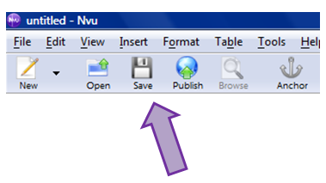
  - Note: It is highly recommended that you save frequently. Nvu is not the always a reliable program, and it crashes easily, especially when you are working with images. Once you have initially saved your Nvu webpage, all you need to do is click the “Save” icon. This icon will be highlighted any time you add anything to or revise your webpage; it signals that you have new changes to save.

Adding Text

- You can add text in two ways: (1) typing it in yourself, and (2) pasting it in from elsewhere. You can edit the text using the toolbox located at the top:

- As noted above, this toolbox is quite similar to those in Microsoft Office programs. This toolbox allows one (going left to right) to select the font; change the text color and background color; change the size; bold, italicize, and underline; number and bullet items; align and indent text; etc.

  - Note: The available fonts are limited and the sizes don’t come in number points (e.g., 12 pt.), just bigger and smaller.

Adding Images

- You cannot copy and paste an image into Nvu. Rather, you must first find an image and save it in the same folder as your Nvu webpage and other miscellaneous documents/images. When saving your image, you’ll need to save it as a .jpeg, .gif., or .png.

- Once your image is saved appropriately, click on the “Image” icon in the toolbox.
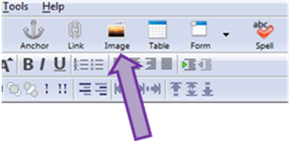

- After clicking “Image,” you’ll see the the following window pop up:

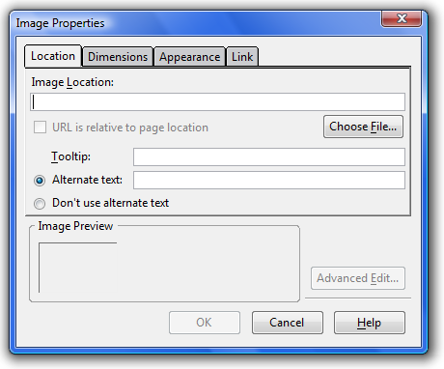

- From here, click “Choose File….” In the window that pops up, locate your image in the folder you saved it to and click “Open.” Now, the name of your image should be in the space for “Image Location:”:

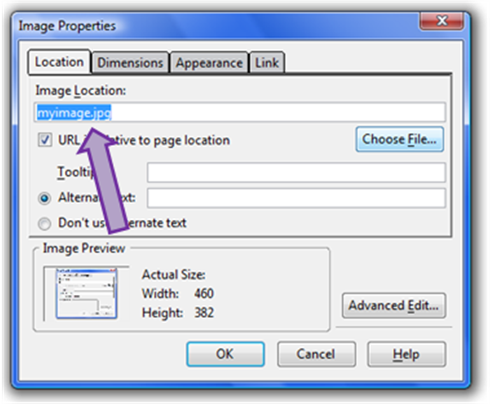

- Next, you’ll need to decide if you want to provide your image with alternative text, which is the text that appears online when you have the mouse positioned over the image. For example:

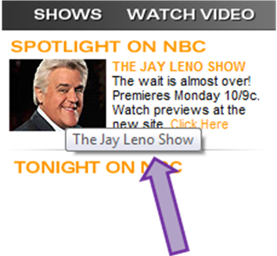

- If you don’t want alternative text, then simply mark the “Don’t use alternative text” option.

- Now, you’ll need to decide if you want to alter the image in any way. To do so, click on the “Appearance” tab:

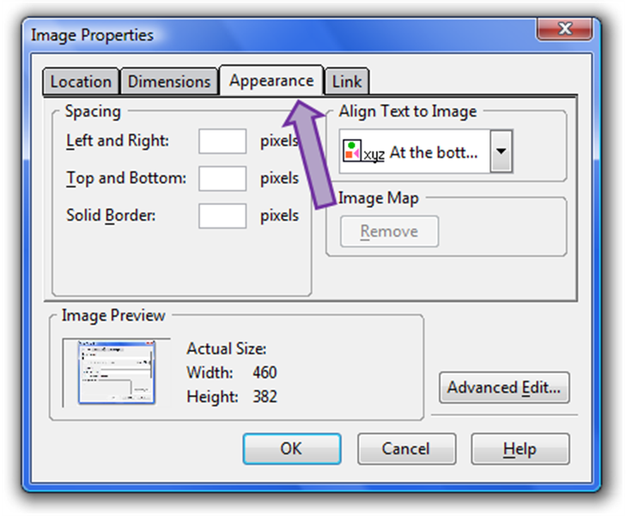
- Here, you can provide spacing for your image (on the “Left and Right” side, the “Top and Bottom,” or both), which acts as an invisible boarder (i.e., a cushion) around the image, which would prevent, for example, written text from running right into the image. You can also text-wrap the image:

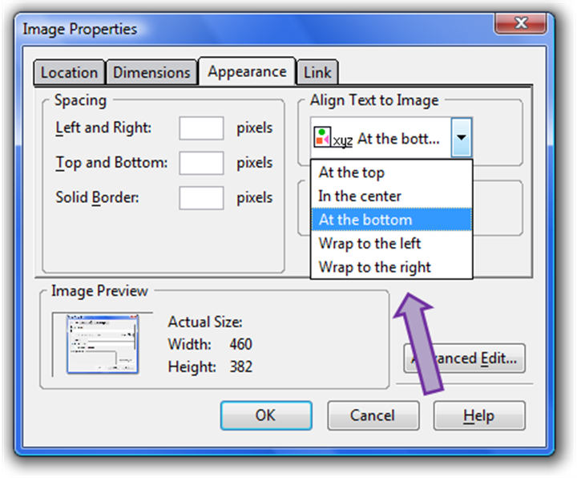

- If you click the “Dimensions” tab, you can adjust the size of the image:

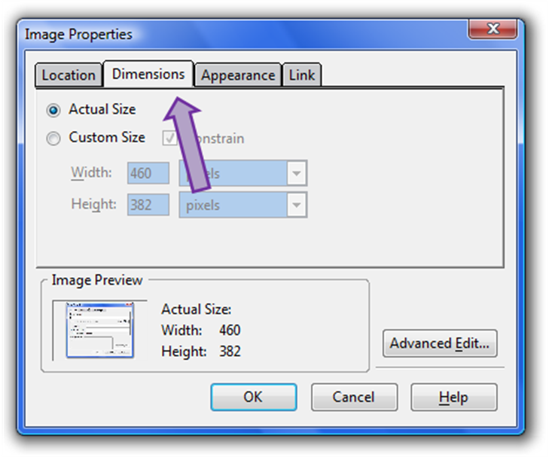

- Once you finish, click the “OK” button and your image will appear on your Nvu webpage. If you click on your image, a rectangle with adjustable nodes will highlight it. If you click and hold one of the nodes, you can alter the dimensions of your image:

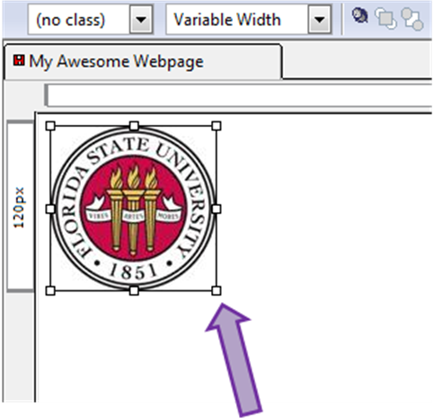

- In addition, you can make the image a layer (meaning you can click on it and place it anywhere on the webpage) by first clicking on your image (highlighting it with the rectangle and nodes) and then clicking on the pin icon underneath the large/small font buttons:

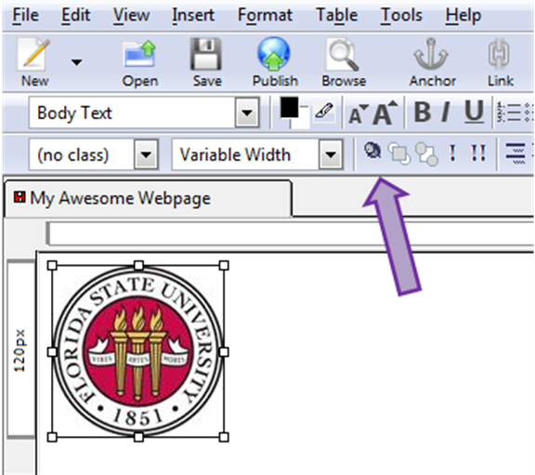

- Note: Layers are beneficial in that you can move the image wherever you want on the webpage; however, using layers can induce headaches, as more often than not, the image moves from where you position it when uploaded and viewed on an Internet browser. If possible, try to text-wrap your images to ensure they stay where you want them.

Adding Tables

- To add a table, click the “Table” icon at the top and a window will pop up that allows you to select your dimensions (e.g., 4x3):

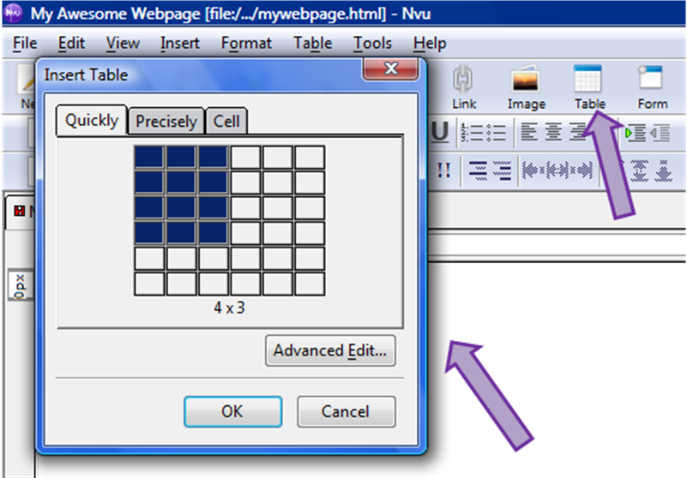

- What you can do with tables:
- Add and delete additional rows and columns; combine rows and columns
- Add text and image(s) into individual cells
- Adjust the boarders (highlight the table, right click, go to “Table Cell Properties,” click on the “Table” tab)

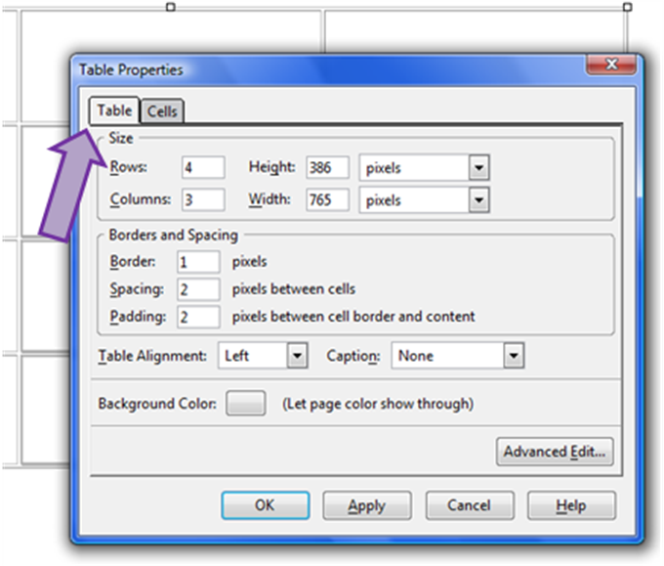

- Here, you can also adjust the number of “Rows” and “Columns”; the “Height” and “Width” of the cells; the “Boarders and Spacing”; the “Table Alignment”; and the “Background Color.”

  - Note: A table border of “0” will highlight the table in red, but when the webpage is uploaded on the Internet, the boarders will be invisible.

Adding Links

- You can make texts and images links to the following:
- Other webpages you’ve created
- Other existing webpages
- Files (such as Word or .pdf documents)

- To link, highlight what you want to be the link (certain written text or an image) and then click on the “Link” icon at the top:

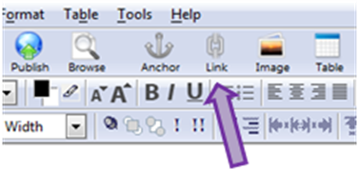
- In the window that pops up, you can either (1) paste the address to an existing webpage or (2) click “Choose File…” and select (a) a different Nvu webpage you’ve created or (b) a file (e.g., .doc, .pdf, .jpeg, etc.).

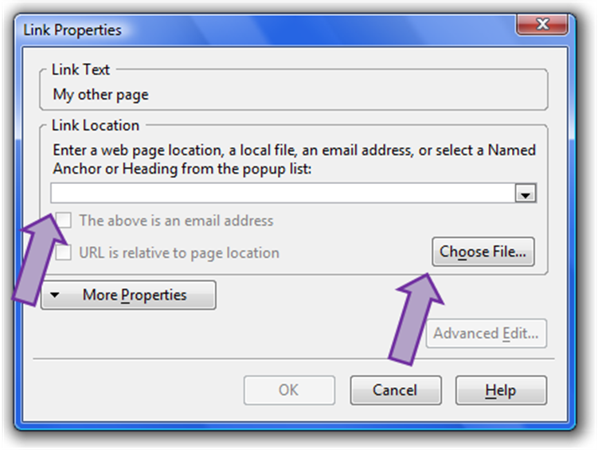

- Note: If you link to a webpage you’ve created or another file, you need to have those webpages/files saved in same folder as everything else.

- Note: The links won’t work on Nvu, only on the Internet.



Adding Video(s) and Music ( )

- You can add YouTube videos by doing the following:
- Find a video you want on YouTube; look to the right; there is an “embed” option with a long line of code under it:

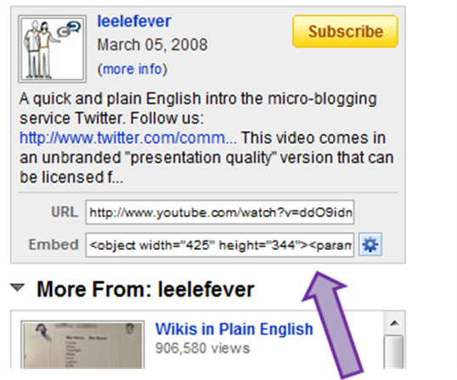

- Copy the whole line of HTML source code and then go to your Nvu page
- Place the cursor where you want the video to show up
- Click “Insert” at the top and then click “HTML…”
- Paste the HTML code for video in the window that pops up:

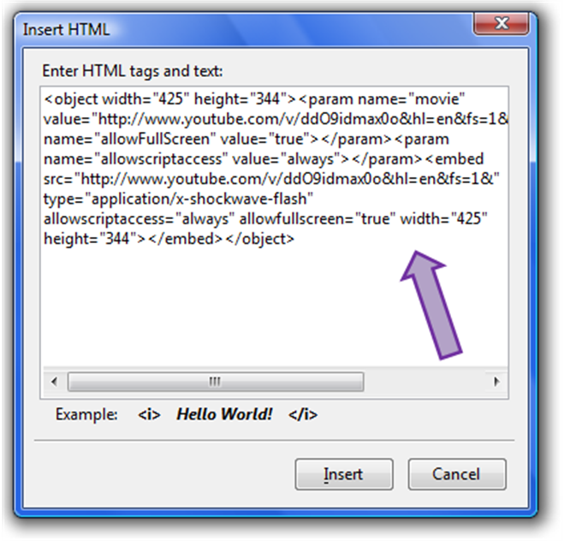

  - Note: The video player will not show up in Nvu; it will only appear once it’s uploaded to the Internet. On Nvu, a blank space will be where the video will be online.

- You can add music by doing the following:
- Go to a webpage like projectplaylist.com that offers the HTML code for songs; you will need to follow the page’s directions, create and account, and pretend you are getting the HMTL code for a Facebook/MySpace page
- Copy the whole line of HMTL source code and then go to Nvu page
- As noted above with inserting a YouTube video, place the cursor where you want the music player to show up
- Click “Insert” at the top and then click “HTML…”
- Paste the HTML code for video in the window that pops up

  - Note: The music player will not show up in Nvu; it will only appear once it’s published to the Internet. On Nvu, a blank space will be there. You might want to paste the music at the bottom of the page.

Uploading Your Webpage(s) to the Internet

- In order to see your Nvu webpage(s) on the Internet, you need to upload the page(s) and all accompanying files and images to SSH.

- To begin, open SSH and then click the “Quick Connect” icon in the upper left corner:

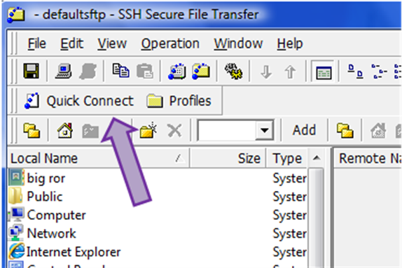

- In the window that pops up, type in the following:
- Host name: english3.fsu.edu
- User name: what your teacher has created for you
- Port: 22 (this never changes)

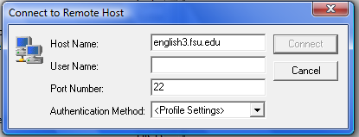

- After clicking “Connect,” you’ll see a window pop up that asks for your password, which your teacher has created:

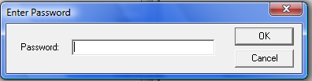

- Now that SSH is connected to the Internet, you can upload your files. Before doing so, you’ll need to refresh the left desktop side by clicking the double green arrows icon:

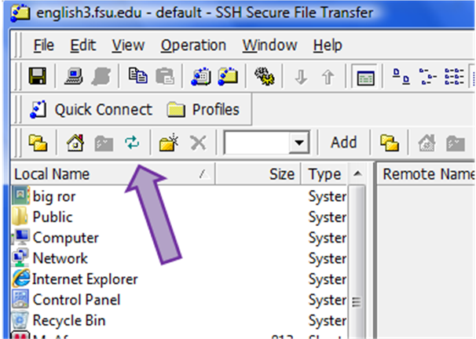

- Next, find the folder on left side that contains all your files (e.g., Nvu webpage(s), images, .doc files, etc.) and find your personal folder on the right side (your teacher should have created this folder for you). Open both of them.

- Drag webpage(s) and all accompanying files and images from the left side into your student folder on the right side.

- Once these files are in the folder on the right, they have been uploaded to the Internet!

